**DATA ANALYTICS**

**EXTERNSHIP PROGRAM**

**MANU PRADEEP KUMAR**

**20BRS1051**

**ASSIGNMENT -3**

**1)DASHBOARD**

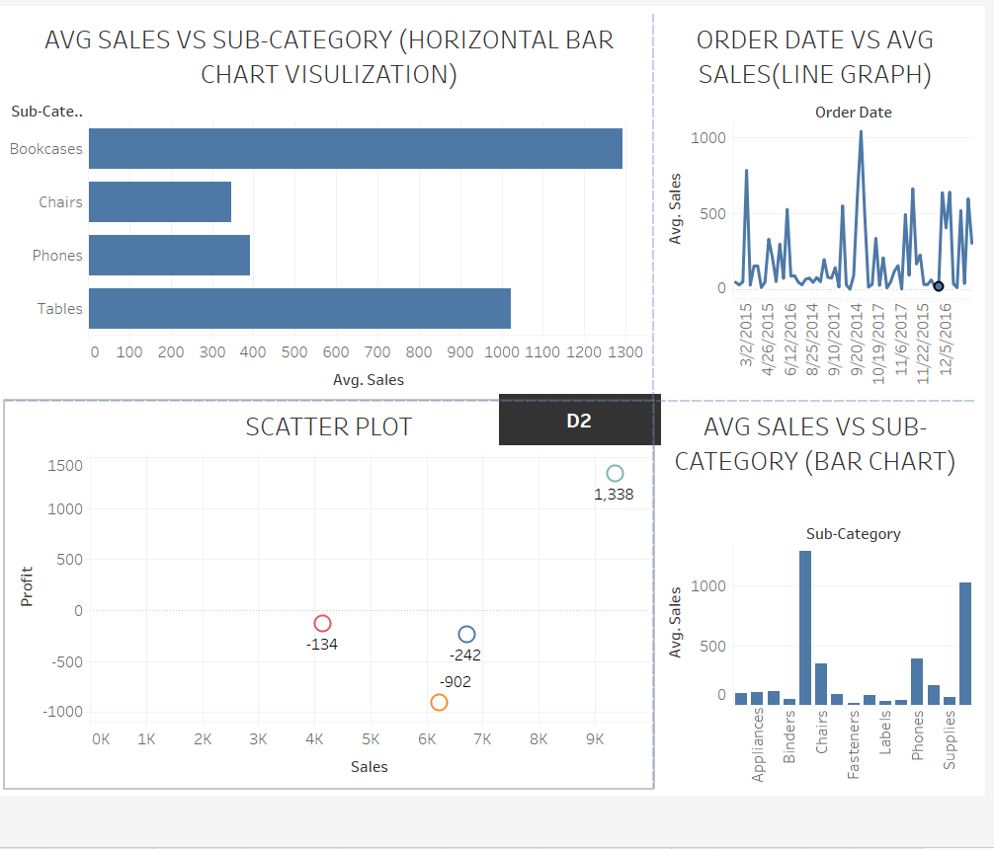

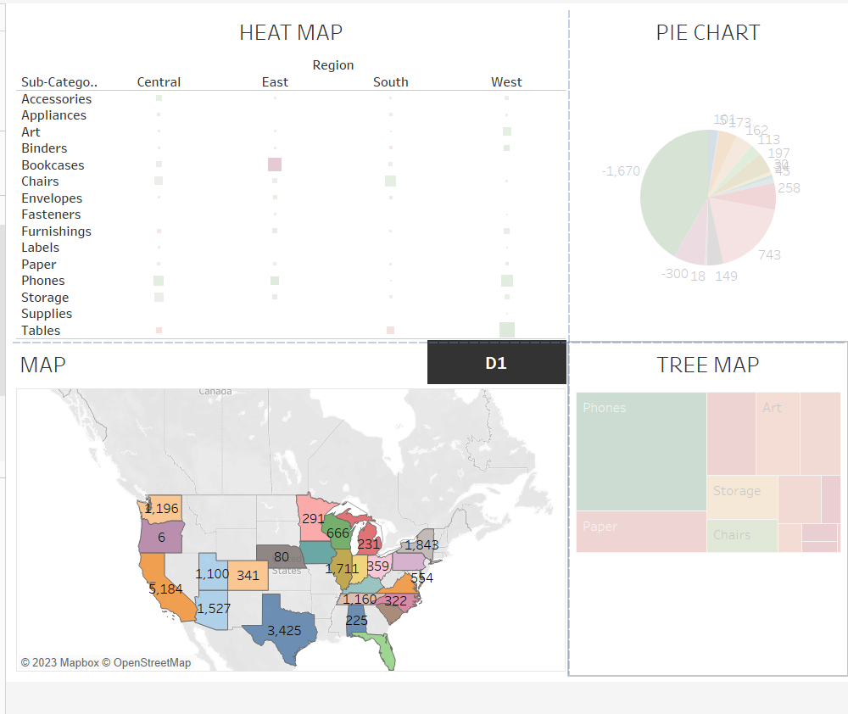

**2)Story**

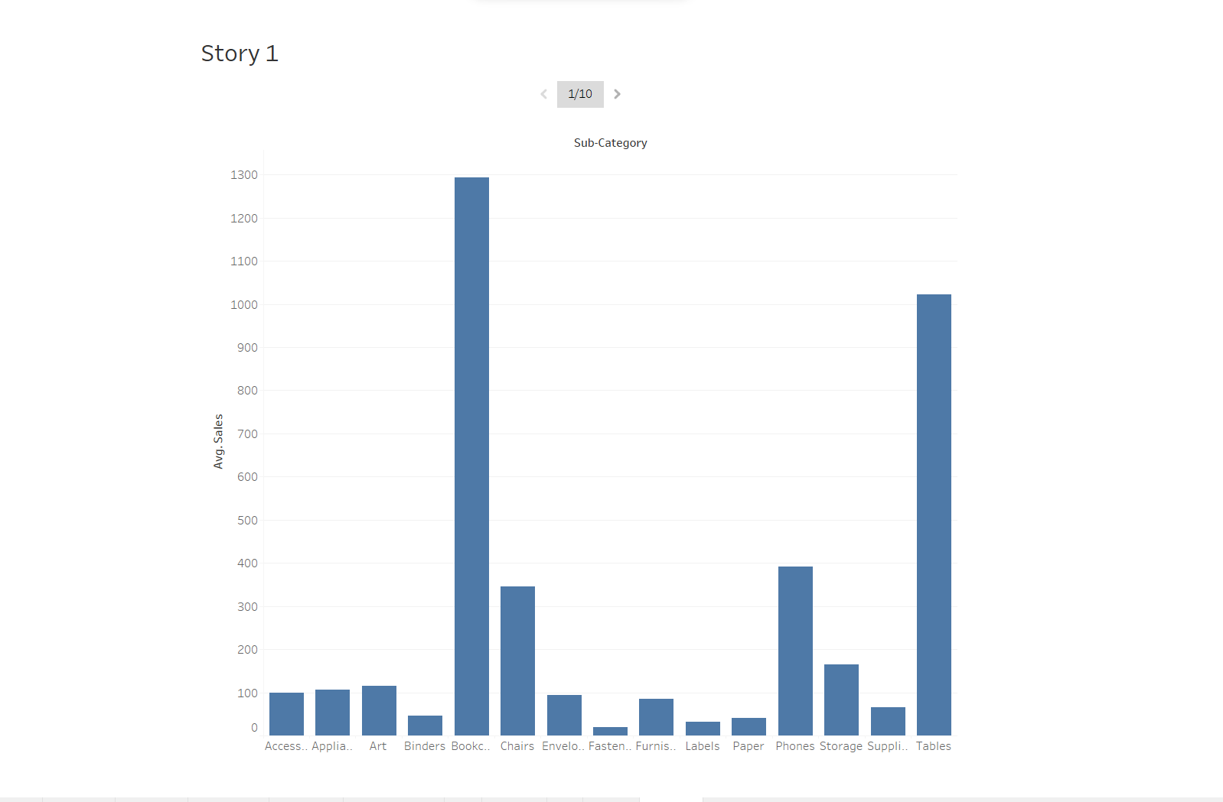

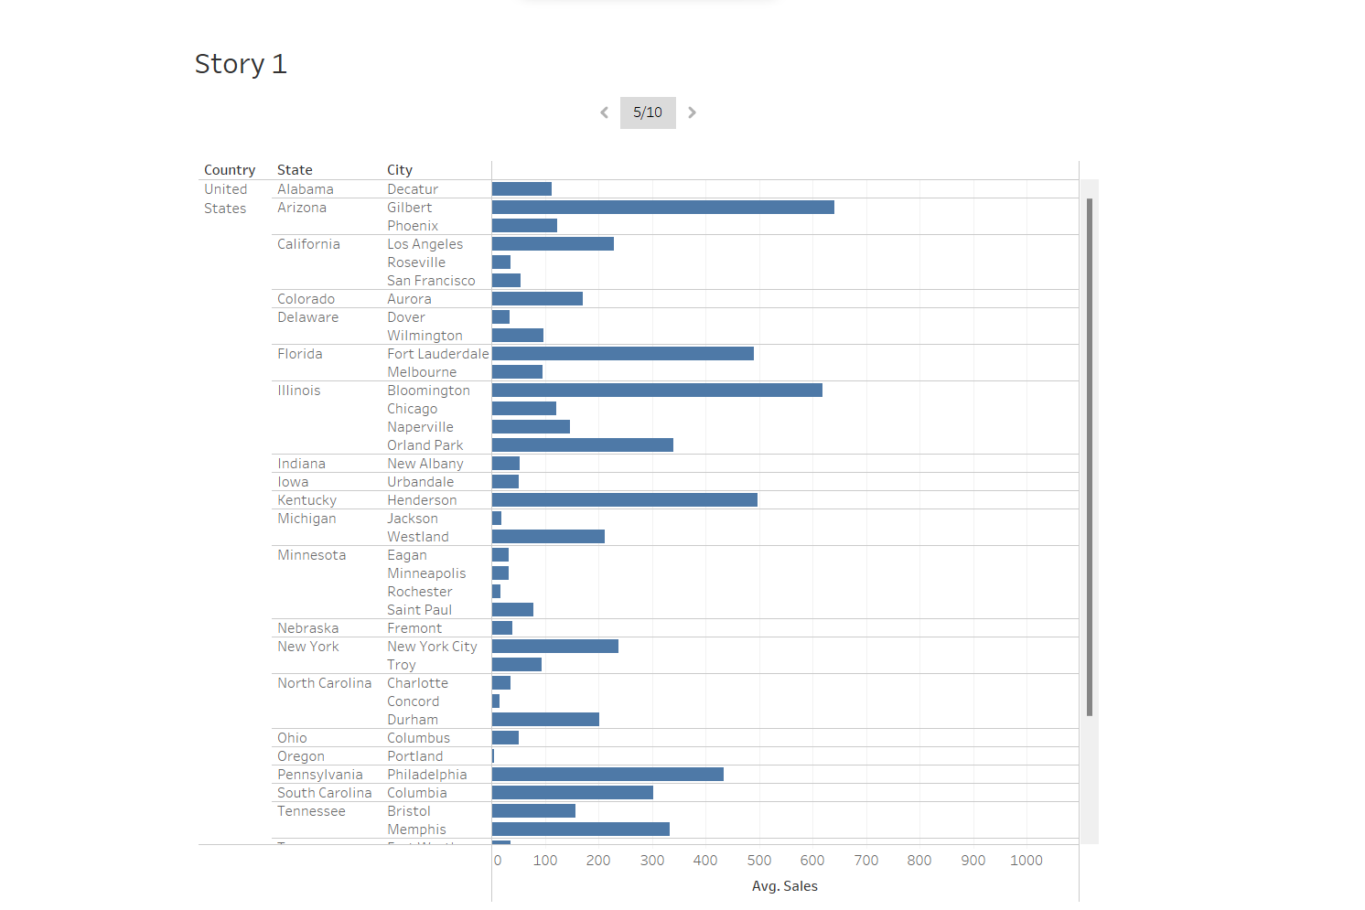

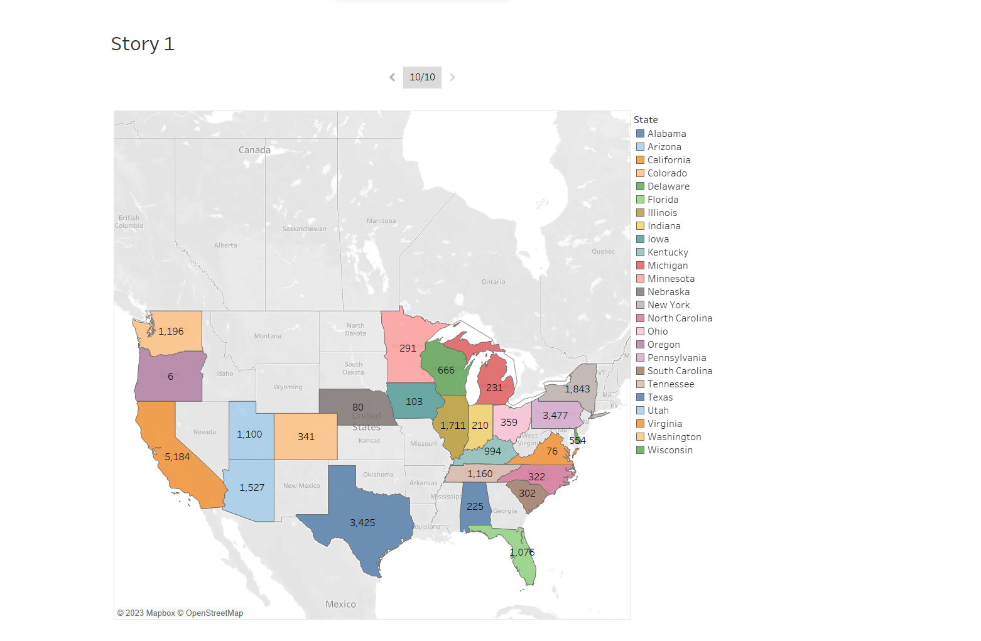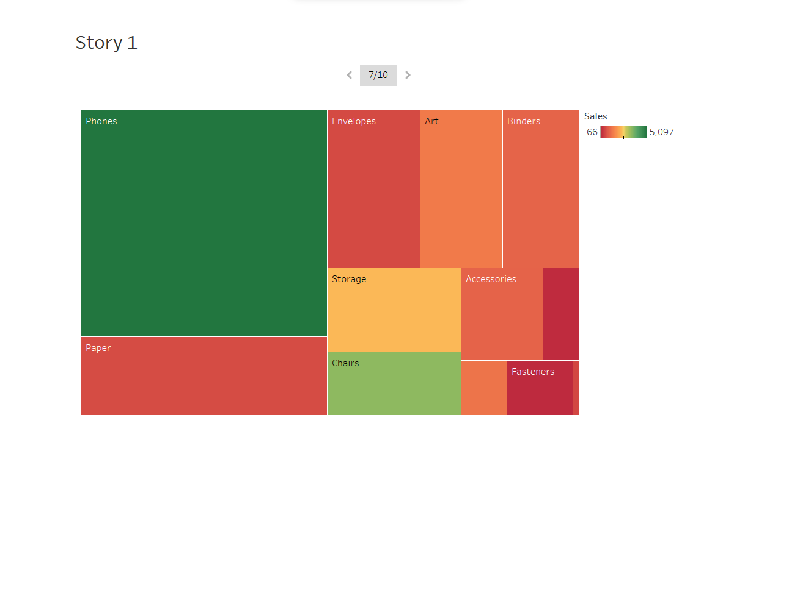

**2)Publishing to servers**

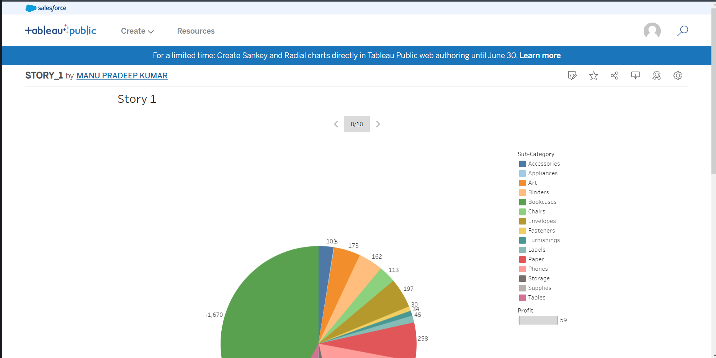

**LINK:** [**https://public.tableau.com/views/STORY_1_16860996697830/Story1?:language=en-US&publish=yes&:display_count=n&:origin=viz_share_link**](https://public.tableau.com/views/STORY_1_16860996697830/Story1?:language=en-US&publish=yes&:display_count=n&:origin=viz_share_link)

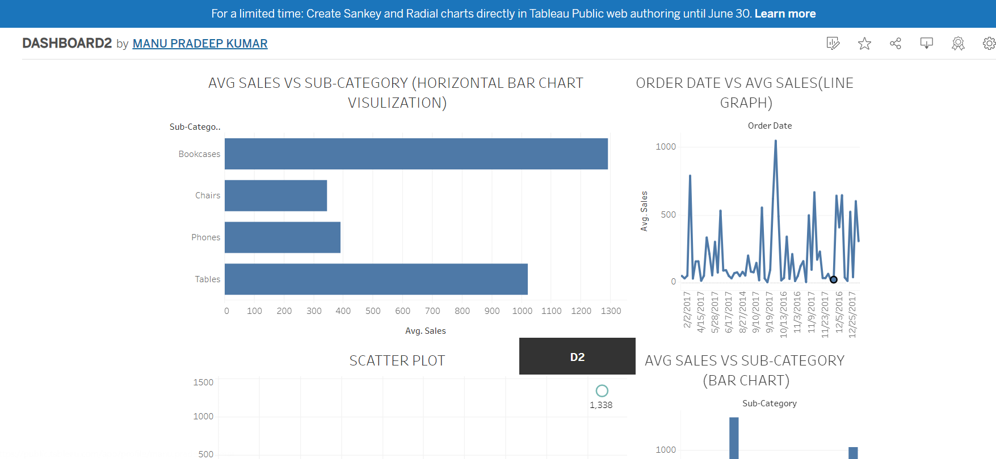

**LINK:**

[**https://public.tableau.com/views/DASHBOARD2_16860999878620/Dashboard1?:language=en-US&publish=yes&:display_count=n&:origin=viz_share_link**](https://public.tableau.com/views/DASHBOARD2_16860999878620/Dashboard1?:language=en-US&publish=yes&:display_count=n&:origin=viz_share_link)

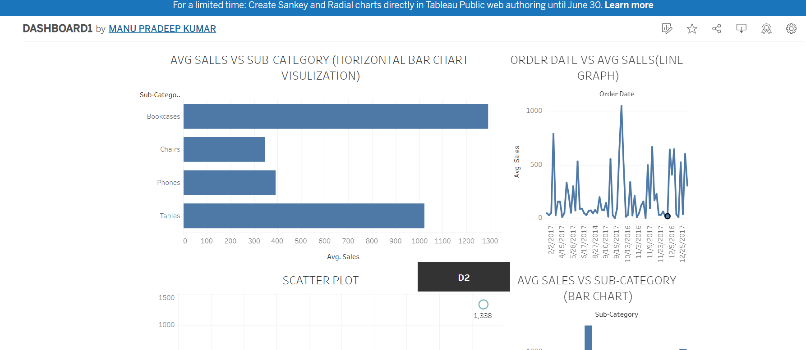

**LINK:** [**https://public.tableau.com/views/DASHBOARD1_16860997696870/Dashboard1?:language=en-US&publish=yes&:display_count=n&:origin=viz_share_link**](https://public.tableau.com/views/DASHBOARD1_16860997696870/Dashboard1?:language=en-US&publish=yes&:display_count=n&:origin=viz_share_link)